Lucas Simmonds  
Charlie Nitschelm

Lab 1  
ME 747  
10/1/2019

**Time and Frequency Response**

1. **First Order System**
   1. **Step Response of a First Order System**
      1. **A**
      2. **A**
      3. **A**
      4. **A**
      5. **A**
      6. **A**
   2. **Frequency Response of a First Order System**
      1. **A**
      2. **A**
      3. **A**
      4. **A**
      5. **A**
2. **Second Order System**
   1. **Step Response of a Second Order System**
      1. Below is the derivation to the differential equation. 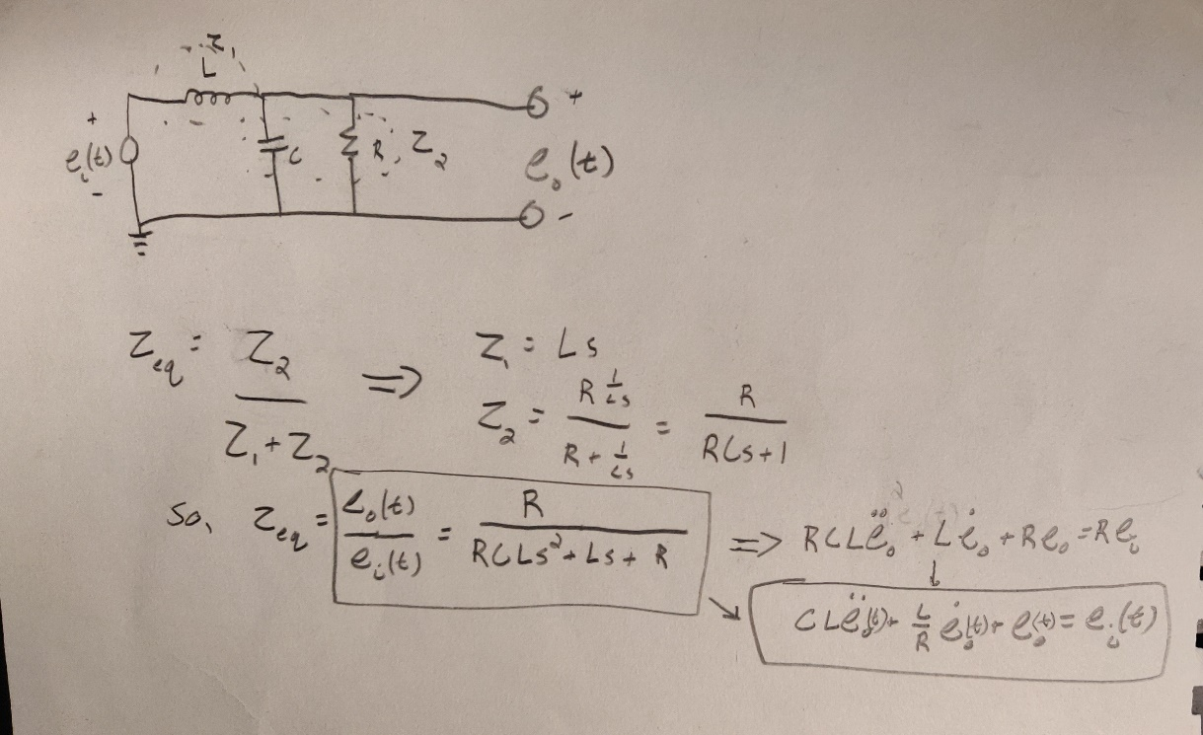
      2. **Using the Log Decrement Method, the values of the experimental damping ratio and the undamped natural frequency can be calculated for both cases.**

|  |  |  |
| --- | --- | --- |
|  | **+-2 Volt** | **-3+5 Volt** |
| **Damping Ratio** | **0.1626** | **.1874** |
| **Undamped Natural Frequency (rad/s)** | **1951** | **2067** |

**What this calculation from the experimental data shows us is that the damping ratio increases slightly with a larger step input. The natural frequency increases slightly with the increase of the damping ratio.**

* + 1. **Below is the table detailing the Inductance and Capacitance values calculated from the damping ratio and the undamped natural frequency:**

|  |  |  |
| --- | --- | --- |
|  | **+-2 Volt** | **-3+5 Volt** |
| **Inductance (H)** | **3.357** | **3.654** |
| **Capacitance (**μF) | **.078** | **.064** |

**From the table, it is clear that inductance increases from a larger step input, while the capacitance of the system decreases as they are inversely related.**

* + 1. **The plots below with different step inputs have similar responses, both settling down at the same time. The theoretical solution curve given the experimental values of R, C and L yield a curve that closely resembles the experimental data, but the natural frequency that is a constant value for the theoretical curve seems to not be sufficient to match the experimental curve for its entirety. This clearly shows that the period of the oscillations in the experimental data is changing slightly every oscillation, causing the two curves to not completely match up. The difference in plots between the two different step inputs is due to the fact that the values of damping ratio and natural frequency change between them, yielding slightly different R, C and L values.**A close up of a map

       Description automatically generatedA close up of a map

       Description automatically generated
  1. **Frequency Response of a Second Order System**
     1. **The table below details the magnitude in dB and phase angle of the frequency response of a second order system**

|  |  |  |
| --- | --- | --- |
| **Frequency (Hz)** | **Amplitude(dB)** | **Phase Shift (deg)** |
| 14.25 | 0.02179647 | -0.25651988 |
| 71.25 | 0.341504021 | -1.542857143 |
| 142.5 | 1.981738645 | -6.942857143 |
| 285 | 9.502997475 | -72 |
| 427.5 | -2.021055162 | -156.5217391 |
| 570 | -8.453984954 | -172.8 |
| 1140 | -21.04216733 | -172.4059293 |

* + 1. **The figure below is the bode plot of the system’s derived transfer function using L and C values derived from the experimental values previously calculated.   
       A close up of a map

       Description automatically generated  
       As you notice, the measured values and the transfer function bode plot are very similar through the spectrum of frequencies before and after the break frequency.**
    2. **Below is the table detailing the differences in determining the damping and natural frequency from the step input data and the frequency response data. The two data sets differ slightly, with the natural frequency yielding almost exactly the same result!**

|  |  |  |
| --- | --- | --- |
|  | **Step** | **Frequency** |
| **Damping Ratio** | **0.1626** | **.1580** |
| **Undamped Natural Frequency (rad/s)** | **1951** | **1952** |

* + 1. **The values below are the calculated C and L values from the step input data and the frequency response data.**

|  |  |  |
| --- | --- | --- |
|  | **Step** | **Frequency** |
| **Inductance (H)** | **3.357** | **3.261** |
| **Capacitance (μF)** | **.078** | **.081** |

1. **Frequency Response Using LabView**
   1. **Frequency Response of a First Order System Using LabView**
      1. **A**
      2. **A**
      3. **A**
   2. **Frequency Response of a Second Order System Using LabView**
      1. **The plot below shows the difference between the bode plot from MATLAB and the experimental recorded values. There is a significant difference between he two curves near the break frequency, with different magnitudes, and a different curve path when decreasing. You can see that noise increases in the experimental data as the frequencies become larger and larger.  
         A close up of a map

         Description automatically generated**
      2. **The table below details the differences between section 2 experimental damping ratio and natural frequency with the calculated values of the frequency response from the LabView data. It is clear that all 3 methods yield similar results, telling us that all methods of measurement yield roughly the same result. It is clear, though, that the LabView data of the entire bode plot data is more different then the other methods of measurement.**

|  |  |  |  |
| --- | --- | --- | --- |
|  | **Step** | **Frequency** | **LabView** |
| **Damping Ratio** | **0.1626** | **.1580** | **.1446** |
| **Undamped Natural Frequency (rad/s)** | **1951** | **1952** | **2241** |

* + 1. **The table below compares all the calculated circuit values of inductance and capacitance. It is clear, again, that the LabView measurements yield slightly different values, creating a different bode plot. The Inductance is lower, while the Capacitance is very similar to the other values, but still slightly smaller.**

|  |  |  |  |
| --- | --- | --- | --- |
|  | **Step** | **Frequency** | **LabView** |
| **Inductance (H)** | **3.357** | **3.261** | **2.598** |
| **Capacitance (μF)** | **.078** | **.081** | **.0765** |